
Week 4 - The 5 Classes of Vertebrates

Vertebrates are animals with a spine or backbone.
Vertebrates as a group can be broken down into further subgroups called classes based on their body covering, how their young are born, and their body temperature.
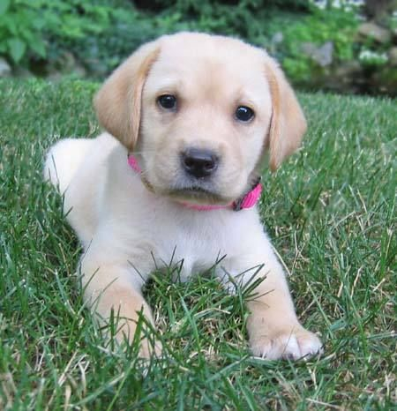
Vertebrates either have a constant body temperature or a body temperature that changes with the environment.

Class Mammalia (Mammals)
Mammalia is a class of vertebrates well known to
many people. Many of our pets belong to this class:
Horses, dogs, cats, rabbits, guinea, pigs and mice.
We also belong to this class.
Mammals are animals with hair or fur and they have a constant body temperature.
Female mammals give birth to live young and feed their young with their milk.

Class Aves (Birds)
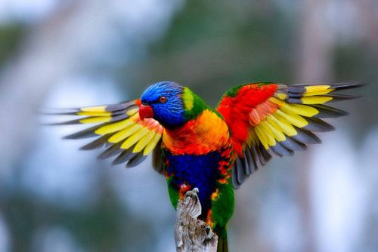
Like mammals, they have a constant body
temperature. Two of their main distinguishing
characteristics are their covering of feathers and
their scaly legs. All animals in this class lay eggs
with a hard shell.

Class Reptilia (Reptiles)
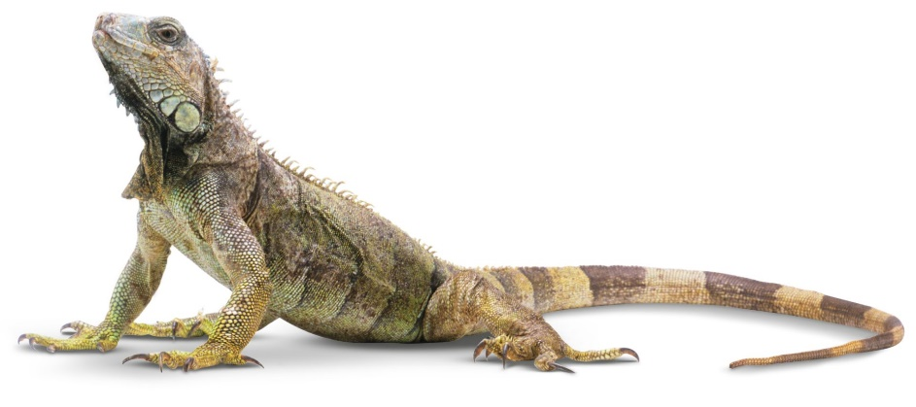
The skin of reptiles, such as snakes and lizards, is usually covered in a layer of fine scales.
Reptiles use lungs to breath even if they live under water.
Reptiles use their environment to regulate their body temperature.

Class Amphibia (Amphibians)
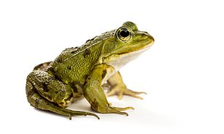
Like reptiles, amphibians use their environment
to regulate their temperature. Amphibians are
usually soft and slimy to touch. They lay their
eggs without shells in water. As they get older,
lungs develop and they become able to live on
land.

Class Pisces (Fish)
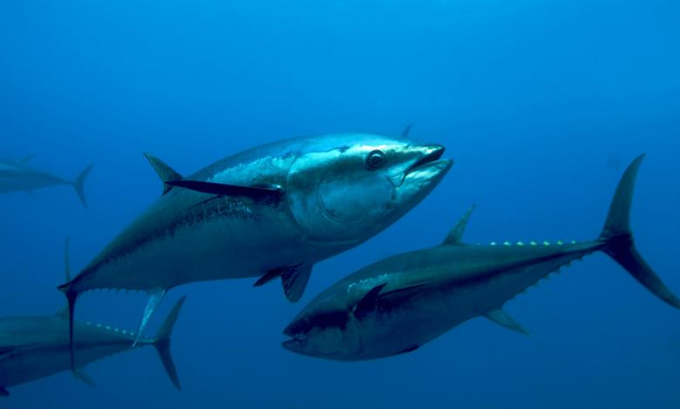
A fish’s body temperature will change
Depending on its environment. They
are covered in a layer of scales and most
have fins. They spend all their life in water
and need gills to breathe.

Task 1 – Questions
- Fill in the table with the above information.
Class of vertebrates | What covers their body? | Are to regulate their body temperature? | How are offspring born? | How do they breathe?
Mammalia

Reptilia

Aves

Amphibia

Pisces

- A dolphin lives in the ocean and has fins. It breaths air, gives birth to live young and feeds them milk. To which class does it belong? Explain.

- A flying fox can glide through the air like a bird but it is covered in fur. To which class does it belong? Explain.

- The Vertebrates have five classes Mammalia, Reptilia, Amphibia, Aves and Pisces. What are the more common names for these classes?

- Explain what each letter below means in MR NGREWW
M
R
N
G
R
E
W
W

- From the things below tick what aspects of MR NGREWW they satisfy and then justify if the item is living or non-living.
Item | MR NGREWW |  | Living or non-living | Justification
Turtle | M  R  N  G  R  E  W  W
Rock | M  R  N  G  R  E  W  W
Chair | M  R  N  G  R  E  W  W
Flower | M  R  N  G  R  E  W  W
Dead tree | M  R  N  G  R  E  W  W
Fire | M  R  N  G  R  E  W  W
Ring | M  R  N  G  R  E  W  W

Task 2 – Class of Vertebrate
Look at the animal below:
Create a table and decide which vertebrate they belong to and provide reasons as to why you classified them as belonging to this class.
Make a branching classification key for the following animals.

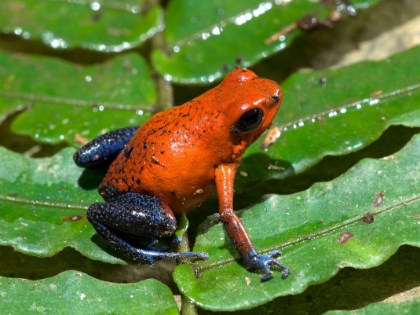
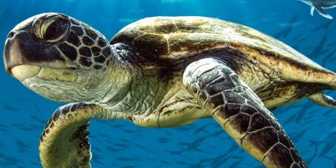

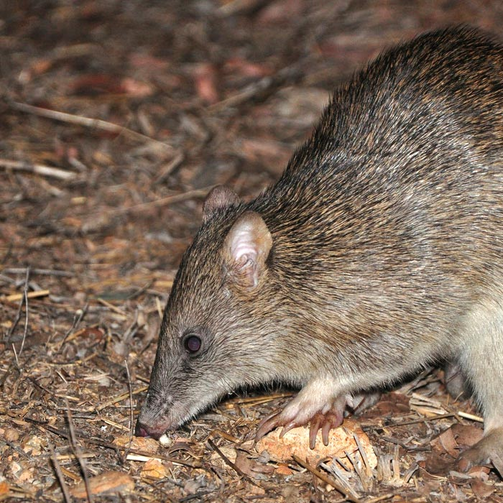

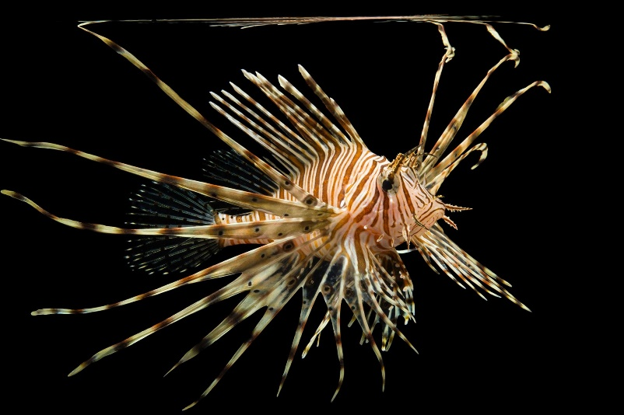

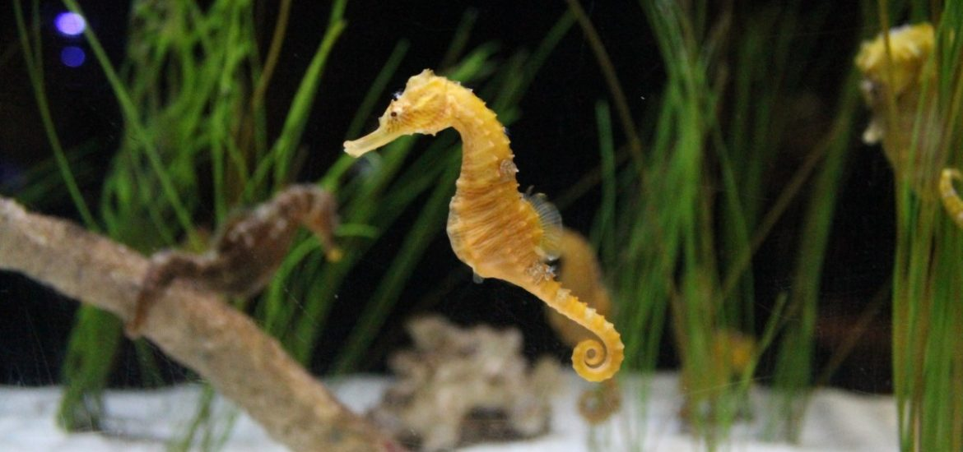

Task 3 – Scientific Names of Local Species
- Research the 5 different animal species that are local to Western Australia.

Common Name of Species | Image of species | Scientific Name of Species | Meaning of Scientific Name


- Research the 5 different plant species that are local to Western Australia.

Common Name of Species | Image of species | Scientific Name of Species | Meaning of Scientific Name

- Using your notes from Week 1, construct a tabular classification key for the species above in the table below.
Question | Species in section | Directions

Cite

Why must I cite my sources?
- I cannot claim the work or ideas of someone else as my own
- Plagiarism is not just when I directly copy words from someone else's work. Plagiarism is also when someone else's work is paraphrased or their ideas are used and claimed as my own
- Referencing has a positive effect and adds credibility to my work
- When I reference correctly, I am demonstrating that (a) I have read widely on the topic and (b) that I am supporting my hypotheses with comments from expert authors and/or reliable sources
- Correct referencing allows the marker/reader to follow-up my references and check the validity of my arguments for themselves.

Surname | Initial | Title of page | Full title of website | Date Written | Internet Address | Date of visit
Brown | J. | ‘Things in Space’ | Astronomy Facts | 1998 | http://www.astronomyfacts.com | 31 July 2019

Picture References:
https://www.pinterest.com.au/pin/301178293800472277/
https://www.pinterest.com.au/pin/58265388899435077/
https://www.dkfindout.com/us/animals-and-nature/reptiles/what-is-reptile/
https://www.dailymail.co.uk/sciencetech/article-6872301/Scientists-want-cut-toes-dead-frogs.html
https://oceana.org/marine-life/ocean-fishes/atlantic-bluefin-tuna
https://abcnews.go.com/Technology/strawberry-poison-frogs-reaching-heat-limit-climate-change/story?id=64739508
https://www.sustainability-times.com/environmental-protection/time-is-running-out-for-the-worlds-embattled-seahorses/
https://www.bushheritage.org.au/species/bandicoots

